# Chapter 4 – Fundamentals explain less and less trade growth

The purpose of this chapter is to provide evidence on how global trade distortions have shifted for the G20 countries between 1995 and 2017[1]. This is conducted in two steps: first, I run a standard gravity model using exporter-time and importer-time fixed effects instead of production and consumption data in order to study whether the fundamental factors (of the gravity equation) have become less (or more) important over time and infer from this whether the distribution of global trade flows has become more (or less) uneven.

Then, I have performed some additional calculations regarding the absolute size of trade costs using the approach by Novy (2013) – given that I had to construct the main dataset for the gravity estimation anyway. As mentioned later on, I could also expand these calculations relatively quickly to use the (state-of-the-art) Simonovska & Waugh (2014) approach.

**Trade fundamentals and the (a)symmetry of trade flows**

The main idea behind my gravity model is the following: the gravity equation consists of three items – a supply term, denoted by the exporter’s production and its multilateral resistance term containing information on the price level in that country, a demand term, denoted by the importer’s consumption and its multilateral term, and a third component relating to trade costs.

The last term consists on the one hand of the time-invariant trade costs relating largely to geography and history, e.g. the distance between countries, whether they share a border / language/colonial history, and on the other hand of other factors – such as trade policy - that change over time.

Given that we are interested in particular in the last term, I can simply take fixed effects for each exporting and importing country and infer the time-variant trade costs from the residuals[2]. This approach, despite its key shortcoming mentioned in footnote 2, allows first of all to say something about how important the fundamental trade factors (exporter, importer FEs, and time-invariant trade costs) have been over the last quarter of the century in explaining trade patterns (via the R squared). In a second step, I take the inverse of the R squared, or more directly the residuals to infer on the relative trade costs over time. What is crucial here is that I mean relative in terms of the distribution between the G20 countries. In other words, I look at how asymmetric the distribution of trade across countries is: if the residuals are small, the trade fundamentals will explain more of the trade patterns and trade will be distributed “as it is supposed to” given each country’s specific factors, and vice versa.

Specifically, the following empirical setup is applied:

Exportsijt = Supplyit * Demandjt * Fixed_trade_costsij * residualijt,, where

Fixed_trade_costsij = distanceij + borderij + common_languageij + colonyij

The subscript i defines the origin country, j the destination country, and t the time dimension. The model has specified as the dependent variable export flows between each country for a given sector at a given time t. This will be regressed on exporter and importer separate fixed effects, as well as time-invariant trade costs: population-weighted distance, common border, common language, and colonial ties (all obtained from CEPII). The remaining variation is then interpreted as country pair-specific trade costs[3], which change over time.

I report the R squared of my regressions (conducted using the PPML method by Santos Silva and Tenreyro (2006)) below, using as the dependent variable trade levels and 5-year trade growth – with and without both-sided 1% outliers of the residuals:

As you see in the figure above, the R squared for trade levels increases until 2000, meaning that the fundamentals explain increasingly more of the trade and trade flows become more evenly/symmetrically distributed across the G20 countries. This trend, however, turns with the beginning of the new century and trade asymmetries increase until the GFC. They pretty much level out in that period until 2013, before decreasing again until 2015 (but not reaching nearly the levels seen before).

As to the R squared for the trade growth regressions, there is a noisy, but far more dramatic fall from 2000 until ca. 2015. And yes, I’ve checked taking out only the 1% outliers gives better R squared than dropping the 2.5% outliers.

Furthermore, you asked me to report the mean value of trade costs through the residuals of my regression. However, please recall that I have importer-time and exporter-time fixed effects on the mean residual for each year will always be centered at zero. I thought instead of what I can do with the constructed data to infer something on trade costs and this is where the following subchapter comes in.

**Symmetric trade costs**

Given the analysis so far, again, we can also say something about the asymmetry of trade flows among the G20 since 1995. I have therefore looked at how else I could say something about the absolute level of trade costs over that time frame.

For this, I use an approach we’ve used before: the trade cost calculation according to Novy (2013). The advantage of it is that relies on very sparse data and give you an tariff ad-valorem equivalent of the trade costs between country pairs. The main disadvantage of it is that assumes symmetric trade costs between country pairs[4].

The trade costs are estimated using the following formula, inspired by the Ricardian model of Eaton & Kortum (2002):

$$τ_{ij}={(\frac{x_{ii}x_{jj}}{x_{ij}x_{ji}})}^{\frac{1}{2(σ-1)}}-1$$

So the trade costs are a fraction between the product of domestic production for domestic production of the two countries and the product of trade between the countries, discounted by factor which depends on the elasticity of trade $σ$. While the original Eaton & Kortum (2002) estimate a trade elasticity of 8.28, Simonovska & Waugh (2014) prove why it actually is 4.00 (and this is well-established by now). I have therefore set $σ$ to 4.00.

A second point worth making is how I have defined xii and xjj. While one would first take GDP of the countries and subtract exports, this would obviously be biased for the service sector. So, instead, what is also widely established is to take manufacturing production which I have obtained from UNIDO and subtract manufacturing exports (all HS codes except agriculture (chapters 1-15) and mining (chapter 25-27)). Furthermore, I use a readily available code from Simonovska & Waugh (2014) to impute any missing production data from UNIDO.

Now, as for the actual evaluation of the estimated trade costs, I have first plotted their distributions for the years 1995, 2005, and 2017 in terms of a PDF and CDF:

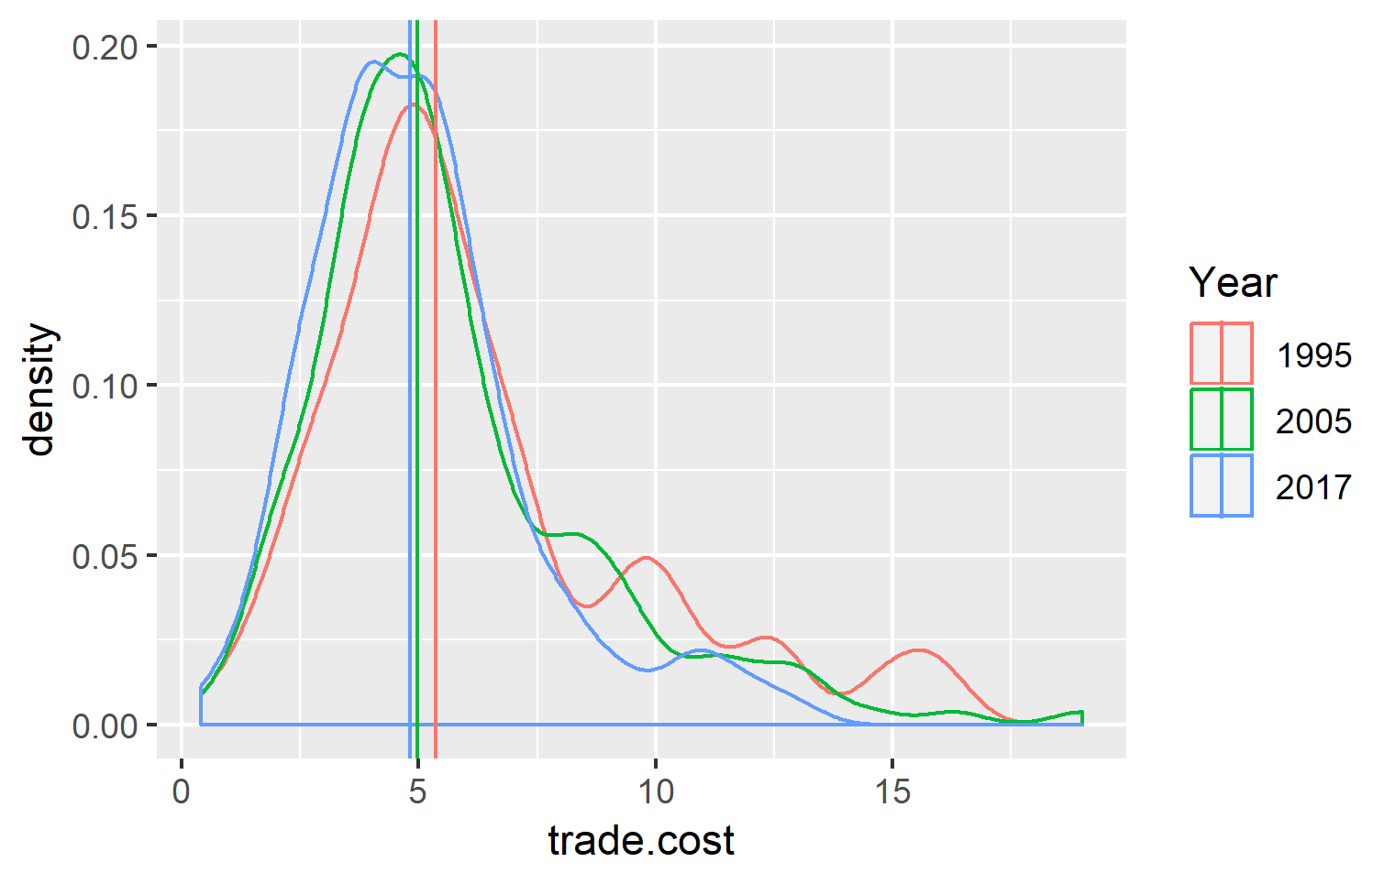

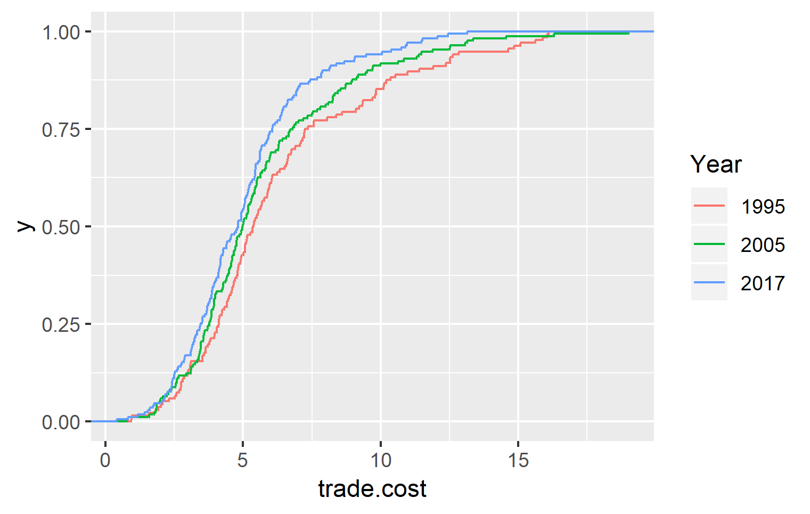

The two figures above may suggest that trade costs have fallen over time especially towards the right side of the tail. However, once I weight them by the actual amount of trade in each year, the story changes:

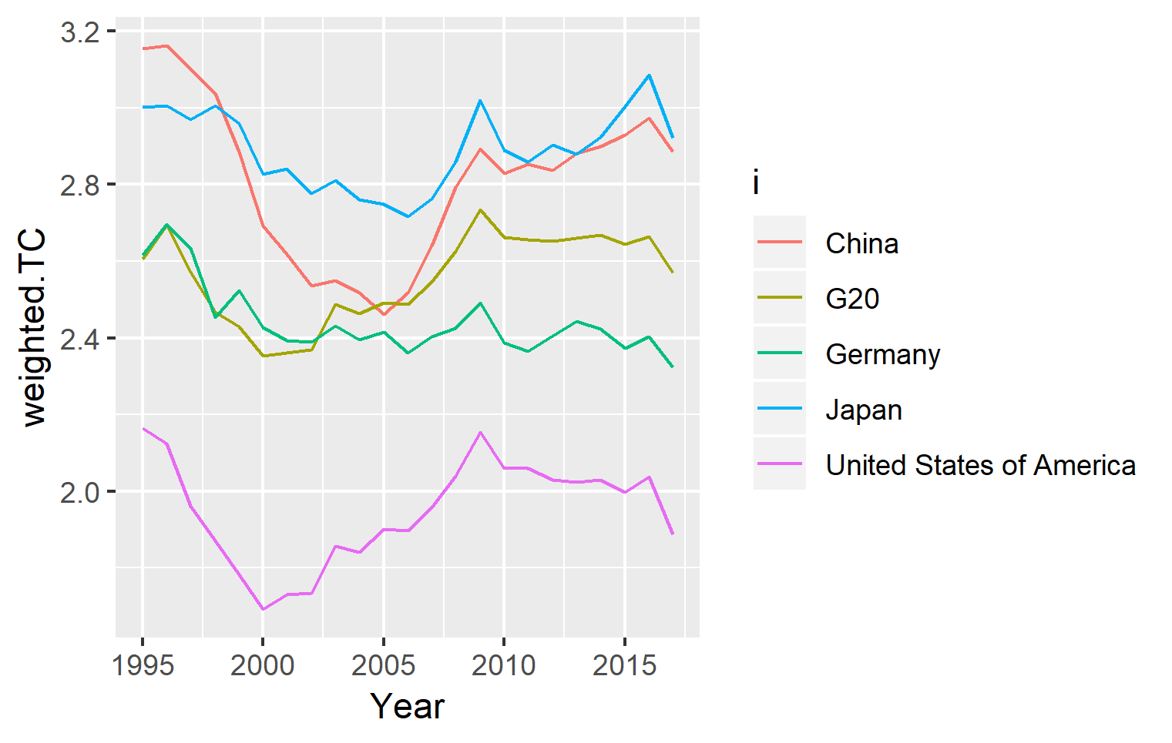

Here, you may see the development of trade-weighted trade costs over time for the main G20 exporters and a G20 average. First of all, I think the charts are roughly in line with what one would expect – do not forget that this, after all, is a ratio between production for domestic consumption and trade.

Also, whereas one should not (oversell and) attribute the general trends only to the state of multilateral trade negotiations, I think the numbers point towards a nice pattern: While the WTO was (somewhat) doing well and growing in the second half of the 1990s, as soon as the Doha Round collapsed (and already during it), international trade flows became less and less important, culminating in record-high trade costs (in the given time frame) at roughly the GFC. Since then, they have overall plateaued at a level previously seen in 1995. The recent fall of trade costs in 2017 (last year in sample) is mainly due to an uptick in trade volumes, seen also e.g. in the World Trade Monitor.

Lastly, I know this not surprising at all, but I do find it quite reassuring that the general pattern seen in the R squared graph can be seen in the figure on trade costs over time as well. If you decide to include both parts of the analysis into the GTA report, I would suggest adding the first and fourth of the four graphs – but not merging them together. That would in my opinion mean too much information for one chart.

**Asymmetric trade costs**

Whereas the Novy (2013) method of estimating trade costs is well-established and provides a good estimate of how these costs have evolved over time, it estimates only country pair trade costs, without differentiating between the direction of the trade flow. Therefore, in the next step, I have conducted an estimation of asymmetric trade costs using the state-of-the-art method developed by Simonovska & Waugh (2014) in their influential Journal of International Economics paper (see in particular equations 22 and 23 on page 40). Please note that this method is conceptually somewhere in between the fixed effects-based gravity estimation conducted in the beginning (it also uses importer and exporter fixed effects, as well as distance and border variables) and the Novy-method for trade cost estimation.

Looking at the (non-trade-weighted) distribution of the trade costs in 1995, 2005, and 2017, we see a gradual decrease in trade costs for the mean, the 25th, and the 75th percentile. However, one should point out that the decrease is much more profound from 1995 to 2005 than from 2005 to 2017. Both trends are very much in line with what we observe in the Novy trade costs.

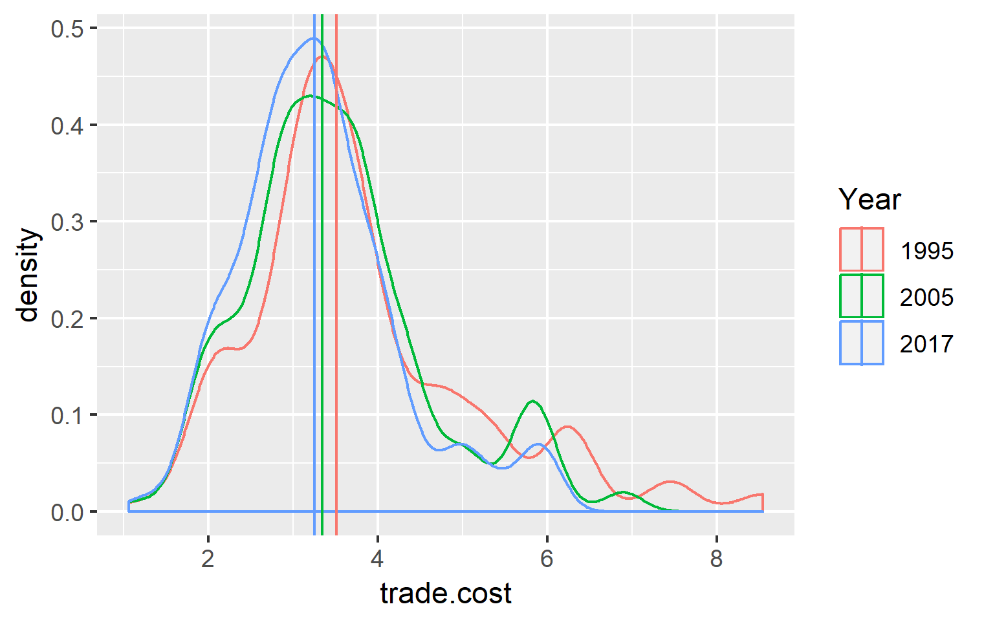

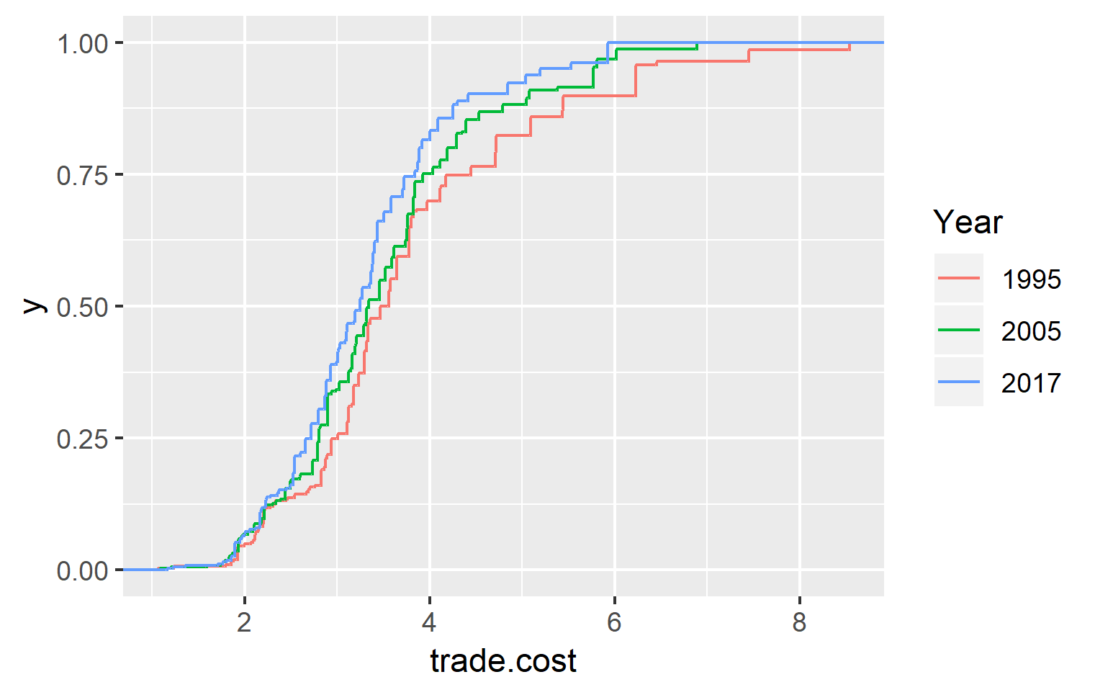

Below, I show the trade-weighted Simonovska-Waugh (2014) trade costs for the four biggest trading countries and a G20 average. The upper chart describes the costs from the export perspective of each country, and the lower one from the import perspective. Of course, the G20 average is the same in both cases.

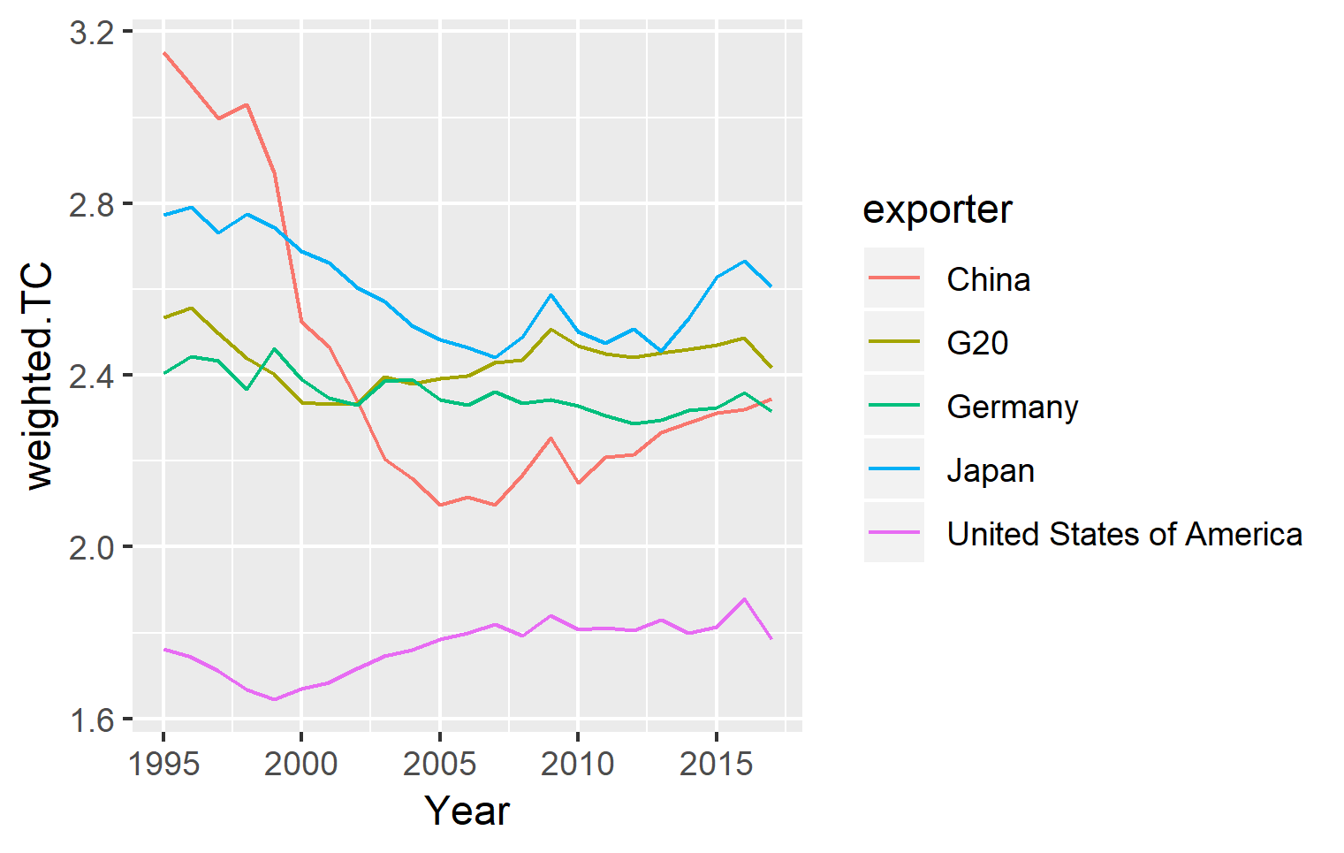

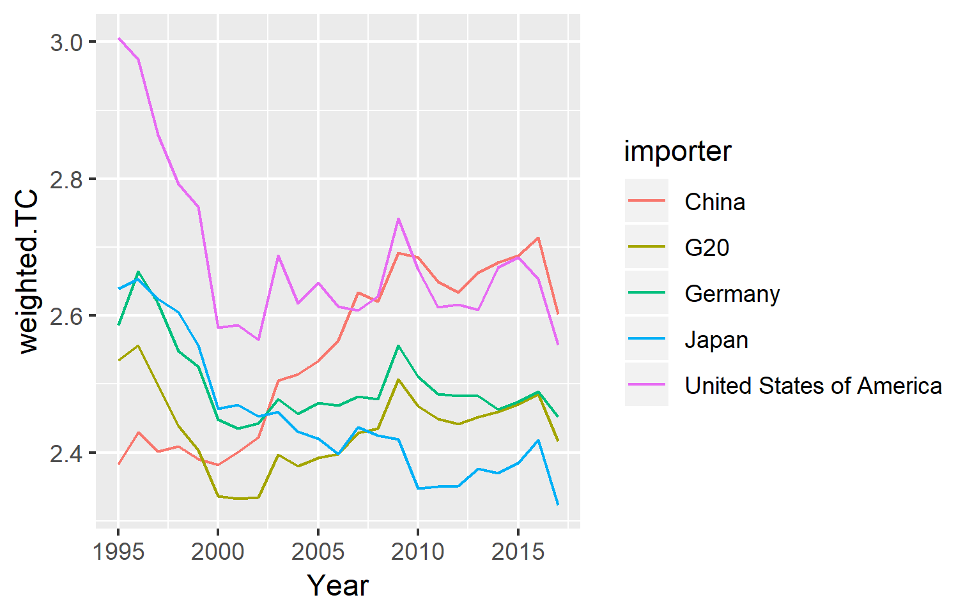

If you compare these last two figures with the trade cost over time figure calculated using the Novy (2013) method, I think a nice pattern emerges: the Simonovska & Waugh (2014) method manages to decompose the trade costs according to exports and imports for particular countries, what leads to some very interesting observations. For instance, whereas the Novy-trade costs for China see a dramatic fall until 2005 and then a steep increase, the decomposition shows that the fall is mainly due to China’s falling exporting costs and the increase is due to the increasing importing costs.

**References**

Eaton, J. & Kortum, S. (2002). Technology, geography, and trade. *Econometrica*, 70(5), pp. 1741-1779.

Novy, D. (2013). Gravity Redux: Measuring International Trade Costs with Panel Data. *Economic Inquiry,* 51(1), pp.101-121.

Santos Silva, J.M.C., & Tenreyro, S. (2006). The Log of Gravity. *The Review of Economics and Statistics*, 88(4), pp. 641-658.

Simonovska, I. & Waugh, M.E. (2014). The elasticity of trade: Estimates and evidence. *Journal of International Economics*, 92, pp. 34-50.

UNIDO. (2019). INDSTAT 2 Database. Source: http://stat.unido.org/database/INDSTAT%202%202019,%20ISIC%20Revision%203

World Trade Monitor. (2019). *CPB Economic Policy Analysis*. Source: https://www.cpb.nl/en/worldtrademonitor .

1. These constraints are mostly set by data availability. All subsequent estimates are based on these countries and years. The only missing values are South Africa before 2000, Russia in 1995, and Saudi Arabia in 1997.
2. In my opinion, the key shortcoming of this approach is that general trade barriers, e.g. if Indonesia generally bans the export of mineral ores and not just to a particular country, will be captured by the fixed effects and not in the residuals. This was also the starting point for my initiative to calculate absolute levels of trade costs using the Novy (2013) method – and possibly also using the Simonovska and Waugh (2014) method (see footnote 4).
3. Given an earlier email about how confident I am that the fixed effects will pick up the RTA formation effect (I am not confident at all), I have rerun all the regressions also including an RTA dummy. As suspected, this barely changes the R-squared and also not the trends over time, given that I have included such variables as distance, or common border and common language already. Nonetheless, you will also see in the first figure the R squared of the regressions estimated with an additional RTA dummy.
4. @Simon: It also allows controlling for such factors as distance or border (which Novy does not).